Root Canal Treatment

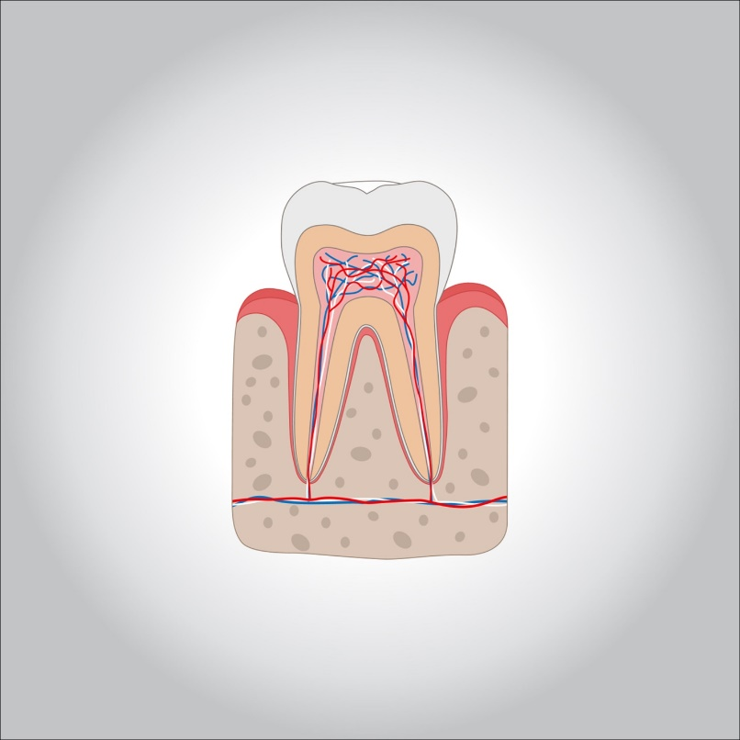

**“Endo” is the Greek word for “inside” and “odont” is Greek for “tooth.” Endodontic treatment treats the inside of the tooth. Root canal treatment is one type of endodontic treatment.**

**Understanding endodontic treatment helps to know something about the anatomy of the tooth. Inside the tooth, under the white enamel and a hard layer called the dentin, is a soft tissue called the pulp. The pulp contains blood vessels, nerves, and connective tissue and creates the surrounding hard tissues of the tooth during development.**

**The pulp extends from the crown of the tooth to the tip of the roots where it connects to the tissues surrounding the root. The pulp is important during a tooth’s growth and development. However, once a tooth is fully mature it can survive without the pulp, because the tooth continues to be nourished by the tissues surrounding it. Learn more about exactly**[**what a root canal is.**](https://www.aae.org/patients/root-canal-treatment/what-is-a-root-canal/)

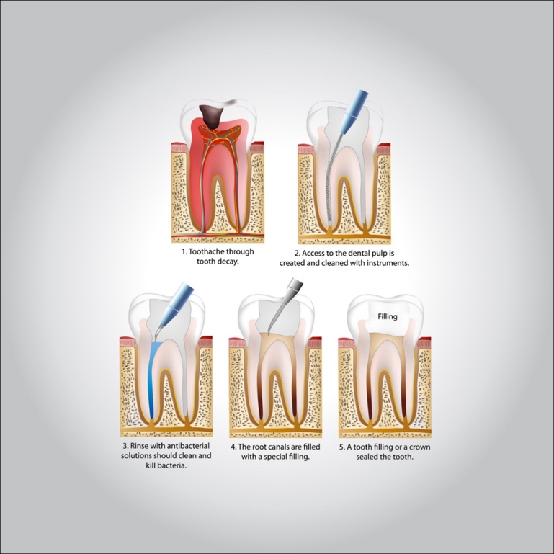

**Endodontic treatment is necessary when the pulp, the soft tissue inside the root canal, becomes inflamed or infected. The inflammation or infection can have a variety of causes: deep decay repeated dental procedures on the tooth or a crack or chip in the tooth. In addition, an injury to a tooth may cause pulp damage even if the tooth has no visible chips or cracks. If pulp inflammation or infection is left untreated, it can cause pain or lead to an abscess.**

**There are a few symptoms that mean you might need a root canal**

* **Severe pain while chewing or biting**
* **Pimples on the gums**
* **A chipped or cracked tooth**
* **Lingering sensitivity to hot or cold, even after the sensation has been removed**
* **Swollen or tender gums**
* **Deep decay or darkening of the gums**

**The endodontist removes the inflamed or infected pulp, carefully cleans and shapes the inside of the root canal, then fills and seals the space. Afterward, you will return to your dentist, who will place a crown or other restoration on the tooth to protect and restore it to full function. After restoration, the tooth continues to function like any other tooth**

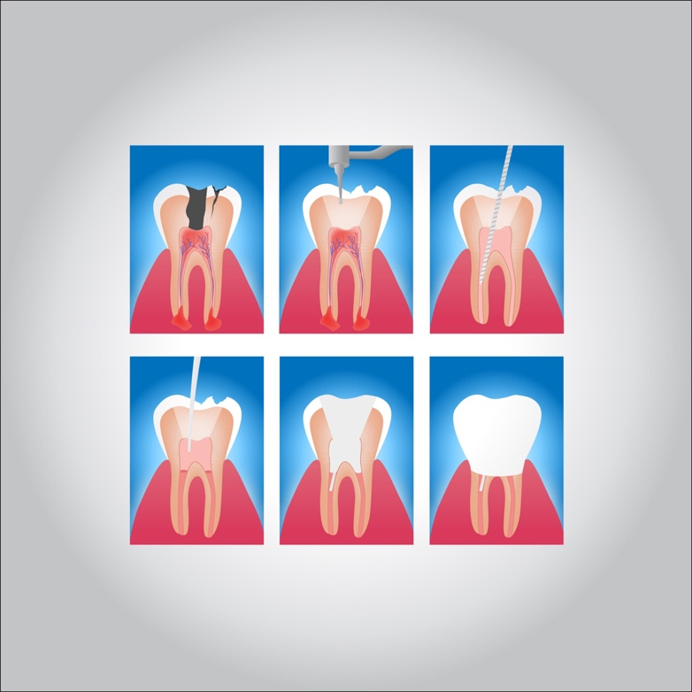

**Many endodontic procedures are performed to relieve the pain of toothaches caused by pulp inflammation or infection. With modern techniques and anesthetics, most patients report that they are comfortable during the procedure.**

**For the first few days after treatment, your tooth may feel sensitive, especially if there was pain or infection before the procedure. This discomfort can be relieved with over-the-counter or prescription medications. Follow your endodontist’s instructions carefully.**

**Your tooth may continue to feel slightly different from your other teeth for some time after your endodontic treatment is completed. However, if you have**[**severe pain or pressure or pain that lasts more than a few days**](http://aae.org/patients/dental-symptoms/tooth-pain/)**, call your endodontist.**

**The cost varies depending on how complex the problem is and which tooth is affected. Molars are more difficult to treat; the fee is usually more. Most dental insurance policies provide some coverage for endodontic treatment.**

**Generally, endodontic treatment and restoration of the natural tooth are less expensive than the alternative of having the tooth extracted. An extracted tooth must be replaced with an implant or bridge to restore chewing function and prevent adjacent teeth from shifting. These procedures tend to cost more than endodontic treatment and appropriate restoration.**

**Protection of the nerves in general done by taking vitamins specially vit. B which is necessary for the nervous system health of course tooth brushing is the most important procedure for the health of the oral cavity.**